Assessment_module_4

● Write SQL query to solve the problem given below.

1.Create a table named as Account holder for the same scenario containing the attributes are account holder’s id, account no, account holder’s name, city,contact, date of account created, account status (active or terminated), account type and balance.

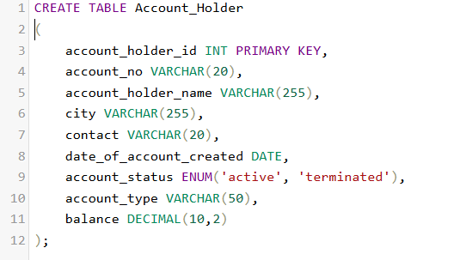

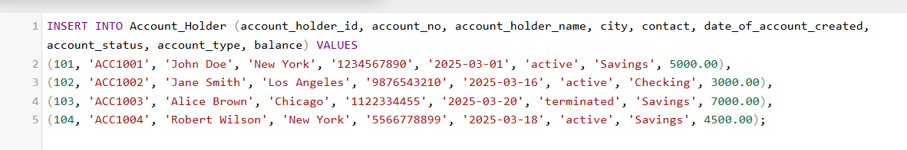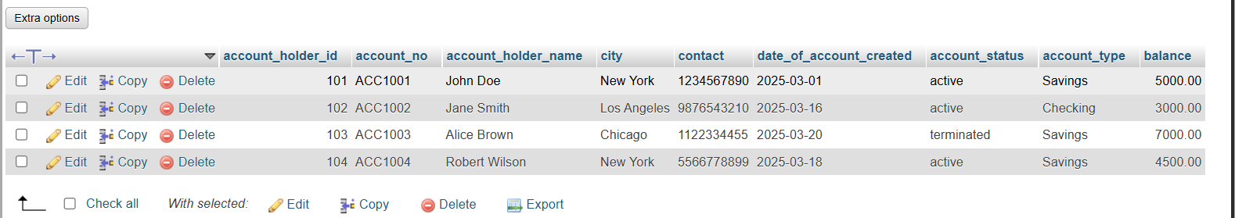

2.Create a Bank table, attributes are : branch id, branch name, branch city.

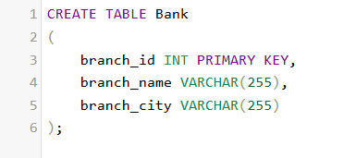

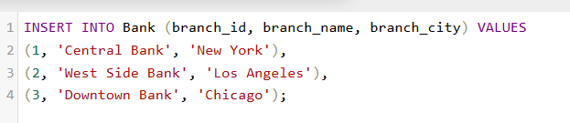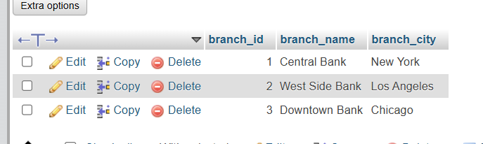

3.Create a Loan table, attributes are : loan no, branch id, account holder’s id, loan amount and loan type.

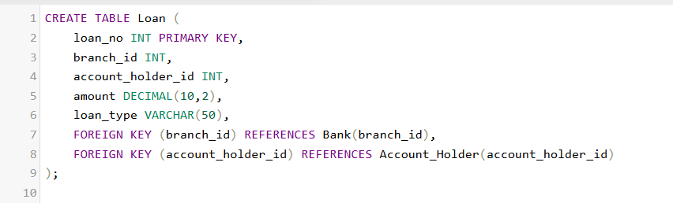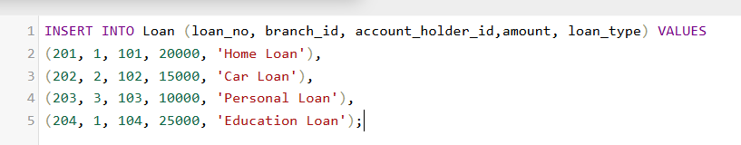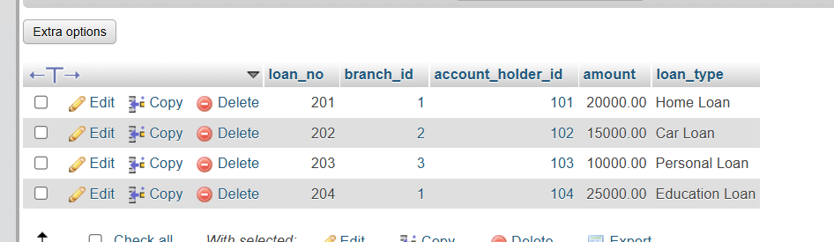

● Consider an example where there’s an account holder table where we are doing an intra bank transfer i.e. a person holding account A is trying to transfer $100 to account B.

- - for this you have to make a transaction in sql which can transfer fund from account A to B

Make sure after the transaction the account information have to be updated for both the credit account and the debited account.

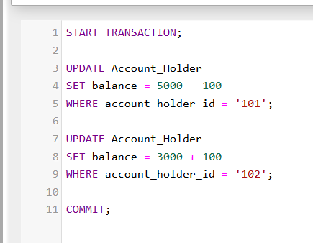

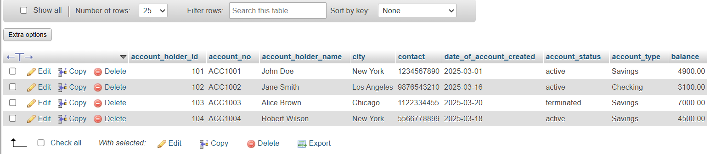

● Also fetch the details of the account holder who are related from the same city.

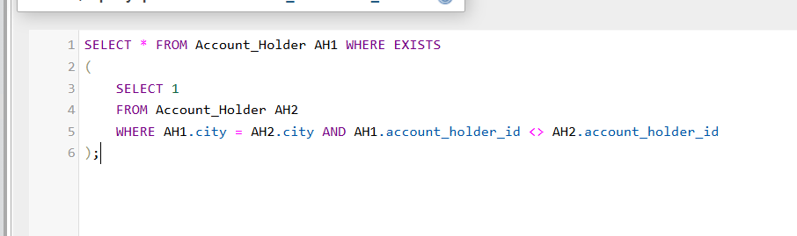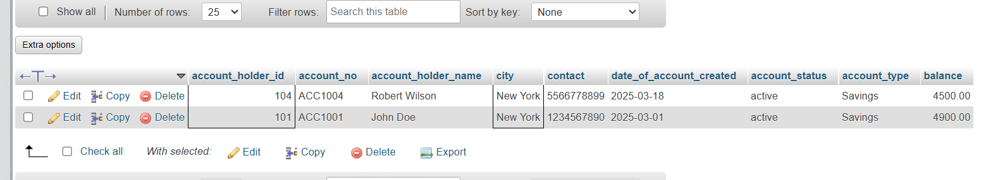

● Write a query to fetch account number and account holder name, whose accounts were created after 15th of any month.

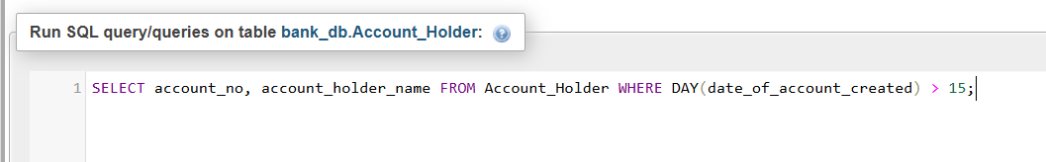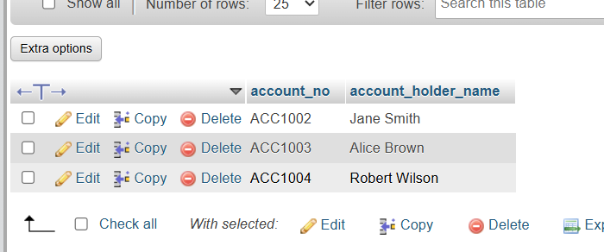

● Write a query to display the city name and count the branches in that city. Give the count of branches an alias name of Count_Branch..

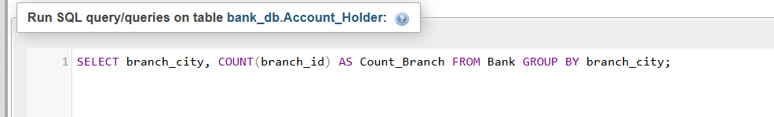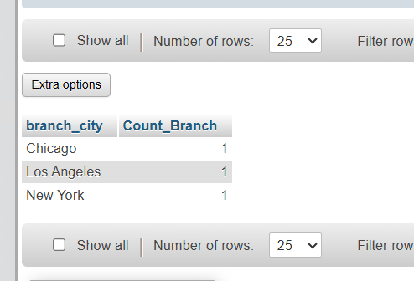

● Write a query to display the account holder’s id, account holder’s name, branch id, and loan amount for people who have taken loans. (NOTE : use sql join concept to solve the query).

